DEFINING TERMS WORKSHEET

Review the following terms and definitions. Next to each definition, write the correct term that correlates with that definition.
TERMS
Bisexual
Cisgender
FTM/MTF
Gay
Gender Identity
Gender Expression
Gender Non-Conforming
Lesbian
Queer
Questioning
Sexual Orientation
Transgender
Transition
Transsexual

DEFINITIONS

1. _________________________________________________: An umbrella term for people whose gender identity differs from the sex they were assigned at birth and/or whose gender expression does not match society’s expectations with regard to gender roles. The term may include identities such as: transsexual, gender queer, gender nonconforming, FTM, MTF, and gender-variant. Transgender people may or may not choose to alter their bodies hormonally and/or surgically.

2. _________________________________________________: An older term for people whose gender identity is different from their assigned sex at birth who seek to transition from male to female or female to male. Many do not prefer this term because it is thought to sound overly clinical.

3. _________________________________________________: A person who is emotionally, physically and/or romantically attracted to some people of more than one gender.

4. _________________________________________________: Refers to a person who transitions from “female-to-male,” meaning a person who was assigned female at birth but identifies and lives as a male. Or refers to a person who transitions from “male-to-female,” meaning a person who was assigned male at birth, but identifies and lives as a female.

5. _________________________________________________: Refers to people who are in the process of understanding and exploring their sexual orientation or gender identity. They are often seeking information and support during this stage of their identity development.

6. _________________________________________________: A person who is emotionally, physically and/or romantically attracted to some other people of the same gender. Can be used to refer to people of all genders, though it is used most commonly to refer to males. Some women and girls choose not to identify as gay, but as lesbian.

7. _________________________________________________: A term for when someone’s gender identity/expression matches their assigned sex at birth.

8. _________________________________________________: The process when a person begins living as the gender with which they identify rather than the gender they were assigned at birth, which often may include changing one’s first name and dressing and grooming differently. Transitioning may or may not also include medical and legal aspects, including taking hormones, having surgery or changing identity documents (e.g. driver’s license) to reflect one’s gender identity. Transitioning is not a one-step procedure; it is a complex process that occurs over a period of time.

9. _________________________________________________: A person who doesn’t adhere to societal pressures to conform to gender norms and roles.

10. _________________________________________________: A woman who is emotionally, physically and/or romantically attracted to some other women.

11. _________________________________________________: An umbrella term used to refer to lesbian, gay, bisexual and transgender people. Some use as an alternative to “LGBT” in an effort to be more inclusive. Depending on the user, the term has either a derogatory or an affirming connotation, as many within the LGBT community have sought to reclaim the term that was once widely used in a negative way.

12. _________________________________________________: Determined by one’s emotional, physical and/or romantic attractions. Categories of sexual orientation include, but are not limited to: gay, lesbian, attracted to some members of the same gender; bisexual, attracted to some members of more than one gender; and heterosexual, attracted to some members of another gender.

13. _________________________________________________: How an individual identifies in terms of their gender. Since gender identity is internal, one’s gender identity is not necessarily visible to others.

14. _________________________________________________: Refers to the ways in which people externally communicate their gender identity to others through behavior, clothing, haircut, voice and emphasizing, de-emphasizing or changing their bodies’ characteristics. Gender expression is not an indicator of sexual orientation.

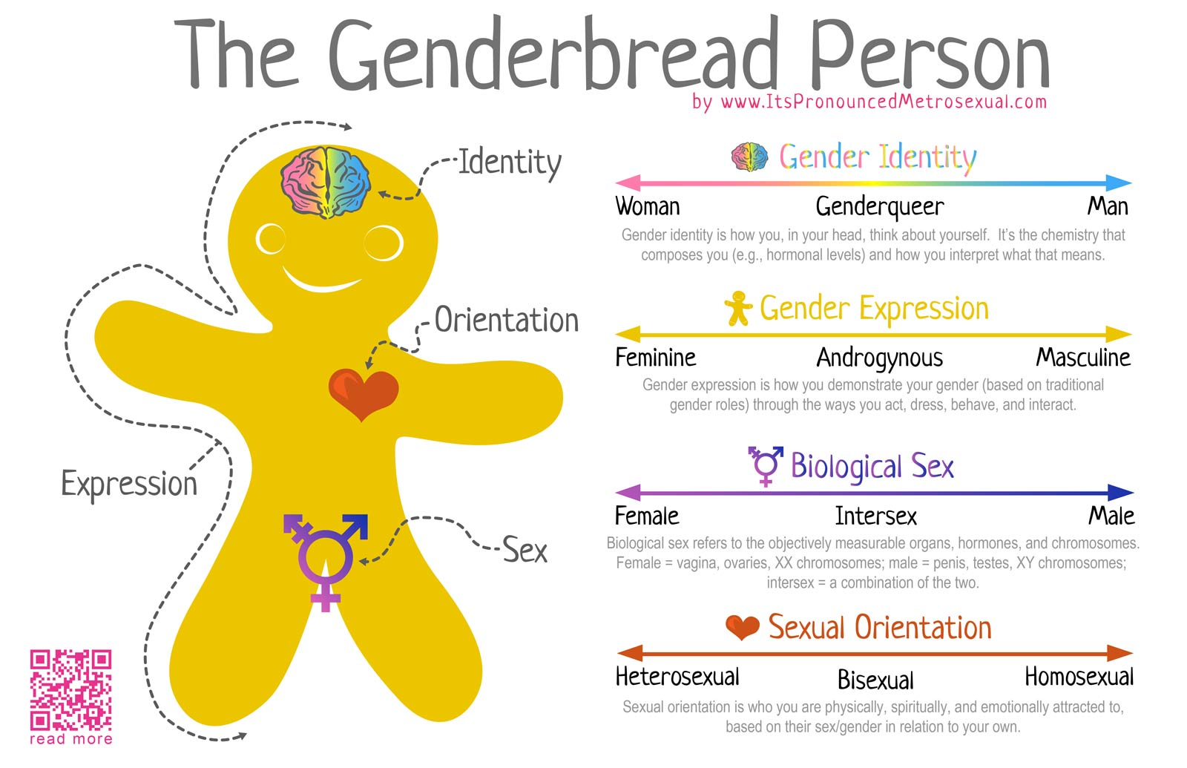

ASPECTS OF IDENTITY CONTINUUM

